**A PROJECT REPORT ON**

**BRIDGE RECTIFIER CIRCUIT**

**Subject : Fundamentals of Electricals and Electronics**



**BACHELOR OF DIPLOMA**

**ENGINEERING IN**

**1 SEMESTER COMPUTER ENGINEERING**

**SUBMITTED BY**

1. ***VEER PATEL***
2. ***KARAN PATEL***
3. ***AAYUSH SANKHAL***

**DEPARTMENT OF 1 SEMESTER COMPUTER ENGINEERING**

**NEOTECH INSTITUTE OF TECHNOLOGY ,VADODARA**

**AFFILATED TO GUJARAT TECHNOLOGICAL UNIVERSITY**

**Index                                                                                      page no.**

**_______________________________________________________**

1. **Bridge Rectifier ………………………….……………………………………….3**
2. **Working ……………………………………………………………………………5**

**2.1Positive half-cycle………………….………………………………………...6**

**2.2Negative half-cycle………………….………………………………………..6**

**2.3Typical Bridge Rectifier……………………………………………………..7**

1. **Part’s of Bridge Rectifier………………………………………………………..**
2. **Use of Bridge Rectifier…………………………………………………………..**
3. **Result……………………………………………………………………………….**

**1.INTRODUCTION TO BRIDGE RECTIFIER**

1. **Bridge rectifier**

* A Bridge rectifier is similar to a full-wave rectifier because it produce a full-wave output voltage.
* It convert Alternating current (AC) to Direct current (DC).
* The process of converting alternating current (AC) to direct current (DC) is know as Rectification.
* The electrical device which is use is know as Rectifier.
* A diode bridge is an arrangement of four or more diodes in a bridge.
* It use four individual rectifying diodes connected in closed loop “Bridge”configuration to produce the desire output.
* The main advantage of this bridge circuit is that it does not require a special center tapped transformer, thereby reducing its size and cost.
* The bridge Rectifier circuit diagram consists of various stages of devices like transformer , Diode Bridge , filtering and regulators
* Generally all this blocks combination is called as a regulated DC power supply that powers various electronic appliances.

**Transformer**

* The first stage of the circuit is a transformer which is a step-down type that change the amplitude of the input voltage. Most of the electronic appliances uses 230/12V transformer to step-down the AC mains 230V to 12V AC supply.
* Next stage is a diode-bridge rectifier which uses four or more diodes depending on the type of bridge rectifier. Choosing a particular diode or any other switching device for a corresponding rectifier need some consideration of the device like peak inverse voltage (PIV), forward current if , voltage ratings ,etc.
* It is responsible for producing undirected or DC current at load by conducting a set of diodes for every half cycle of the input signal.
* Since the output after the diode-bridge rectifiers is of pulsating nature , and for producing it as a pure DC , filtering is necessary. Filtering is normally performed with one or more capacitors attached across the load. This capacitors rating also depends on the output voltage.
* The last stage of this regulated DC supply is a voltage regulator that maintains the output voltage to constant level. Suppose the microcontroller work at 5V DC , but the output after the bridge rectifier is around 16V , so to reduce this voltage and to maintain a constant level – no matter voltage change is input side - a voltage regulator is necessary
* **Advantage:** The main advantage of this bridge circuit is that it does not require a special center tapped transformer thereby reducing its size and cost. The single secondary winding is connected to one side of the diode bridge network and the load to the other side.

1. **Working**

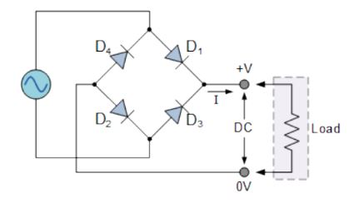

Figure Bridge rectifier

* The four diodes labeled D1 , D2, D3, D4 are arranged in “series pairs” with only two diodes conducting current during each half-cycle.
* Diodes D1 and D2 conduct on positive half-cycle and D3 and D4 conduct on the negative half-cycle
* As a result , the rectified load current flows during both half-cycles.
* During both half-cycle , the load voltage has the same polarity and the load current is in the same direction.
* The circuit has change the AC input voltage to the pulsating DC output voltage.

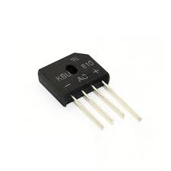

**2.1 Positive half-cycle**

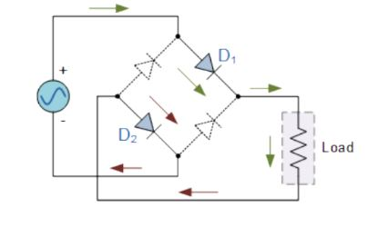

Figure 2 Positive half-cycle

* During the positive half-cycle of the supply ,diodes D1 and D2 conduct an series while diodes D3 and D4 are reverse biased and the current flow through the load.
* This produce a positive load voltage as indicated by the plus-minus polarity.

**2.2 Negative half-cycle**

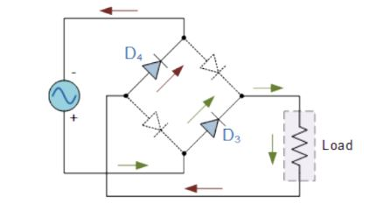

* During negative half-cycle of the supply , diodes D3 and D4 conduct in the series , but diodes D1 and D3 switch “OFF” as they are now reverse biased.
* The current flowing through the load is the same direction as before.
* This also produce a positive load voltage.
* As the current flowing through the load is unidirectional , so the voltage developed across the load is also unidirectional the same as for the previous two diodes full-wave rectifier , therefore the average DC voltage across the load is 0.637Vmax.

**2.3 Typical Bridge Rectifier**

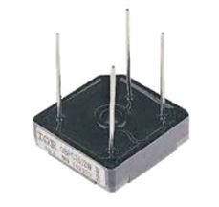

Figure typical Bridge Rectifier

* This is typical single phase bridge rectifier with one corner cut off. This cut off corner indicates that the terminal nearest to the corner is the positive or +ve output terminal or lead with the opposite (diagonal) lead being the negative or -ve output lead.
* The other two connecting lead are for the input alternating voltage form a transformer secondary winding.

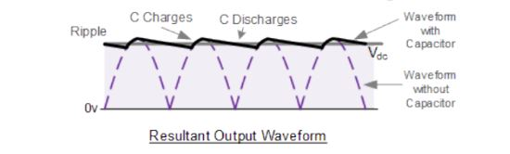

Figure